1. Create a one-paragraph conclusion of what you have learned during the lab today.

I learned about how I can apply it at my html document. CSS is a Cascade style sheets is a efficiently way to give format to html code for internet. I learn to it has a three form to apply it and I practice in a hand on practice applying knowledge in class. Lastly, CSS can refer to elements of html by element, class and ID. Its form to apply stylus was for me very interesting.

1. Create a one-paragraph conclusion of what you have learned during the lab today.
   1. <https://www.arm.gov/>
   2. ARM Research Facility
   3. The target of this web page is all people and institution in relation with atmospheric and climate research.
   4. **Contrast** is not much applied. It appear very similar at use uf colour, font style and size, and sizes of components. **Repetition** is applied according to segments are separated. It able to identified sections in web page. **Alignment** is consistent and properly. It distribute content sorted and in clear position. Proximity is poor implemented. It could have better definition of related content if spaces were implemented in correct disposition.
   5. I would recommend three improvements.
      1. **Equilibrate content disposed at left column removing 2 items.**

Original page

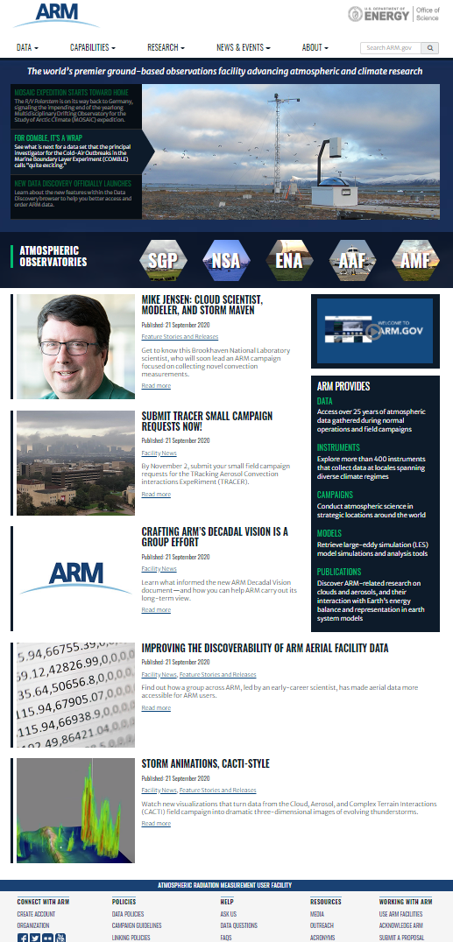

Recommended

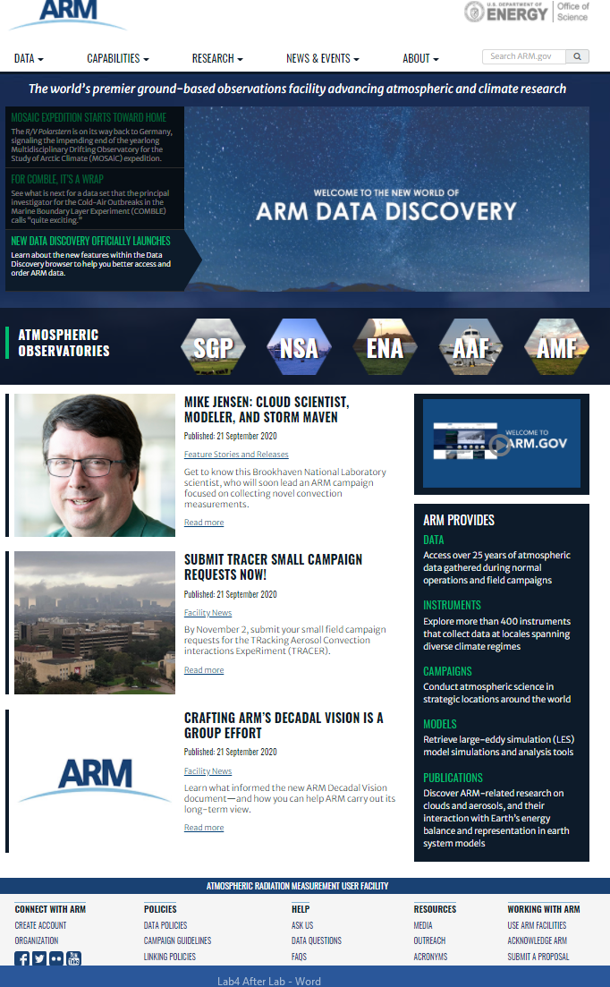

* + 1. **I would recommend use in better way space specially interline and between components.**

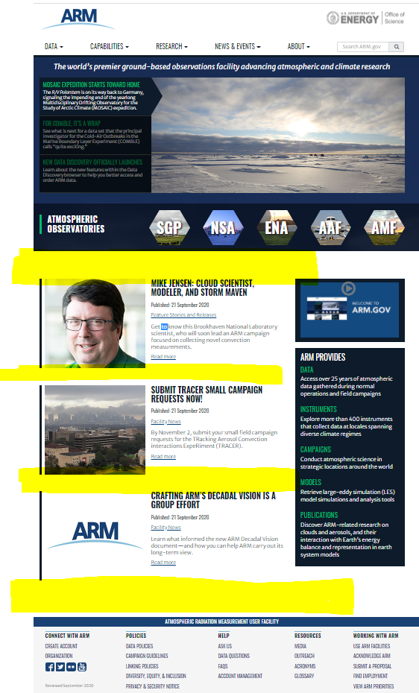

1. **I would recommend use more space interline.**

Original

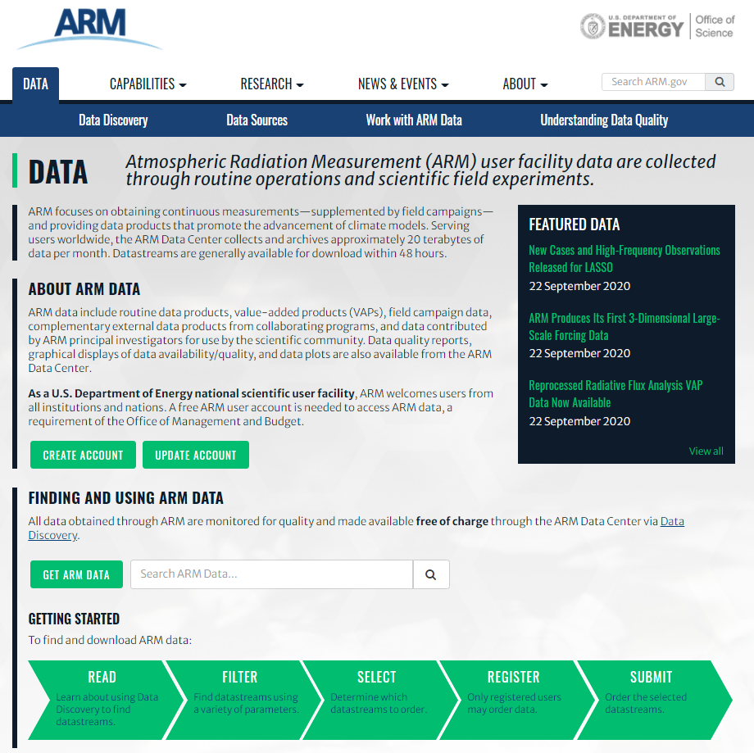

Recommended

